**DECLARATION:** I understand that this is an **individual** assessment and that collaboration is not permitted. I have read and I understand the plagiarism provisions in the General Regulations of the University Calendar for the current year, found at <http://www.tcd.ie/calendar>. I understand that by returning this declaration with my work, I am agreeing with the above statement.

# 1(a) What is the difference between Explanatory and Exploratory Visualization

1. Exploratory visualization helps us figure out what the important things are within the data, while explanatory visualization is meant to show us the important and detailed data.
2. Exploratory visualizaion allows us to quickly understand the meaning of data and explanatzzory visualization is not understand easily. But explanatory visualization could provide us with a deeper understanding of the details of the data.

1(b) What are some of the reasons for why visualization is required in the process of data analysis?

1. Help people understand data efficiently. Data visualisation is a very clear way of communicating those complex messages with a few short graphics. This is because the human brain processes visual information much more easily than written information. Using graphs to summarise complex data ensures that relationships can be understood much more quickly than those in confusing reports or spreadsheets. It is due to this advantage that data visualisation is gaining more and more interest.
2. Help predict future trends. Data visualisation helps people to present complex data in visual charts, such as line charts and bar charts. They all help people to observe trends in data, find underlying patterns and predict future trends.

All in all, No matter what career we are chosen, data visualization is the most efficient way to delivering information and help people understand difficult messages.

2 Have you ever created a visualization of data?

No.

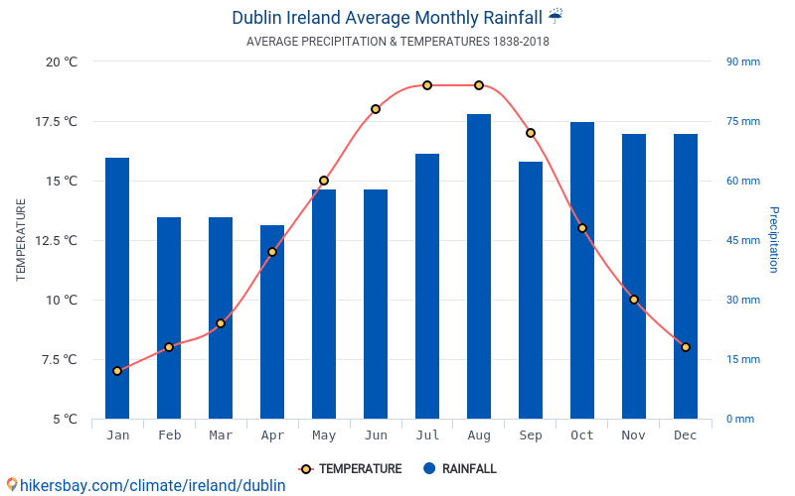

The above graph[1] depicts the average monthly precipitation and temperature for Dublin from 1838 to 2018. The red line represents the temperature and the blue bar represents the precipitation, with the specific data for temperature shown on the left and the specific data for precipitation shown on the right. We can see that Dublin receives between 50 and 60mm of precipitation from February to June, and between 60 and 75mm of precipitation in the other months. The temperature in Dublin varies considerably, starting at 4°C in January and rising to almost 20°C in August, before falling to 8°C in December. The purpose of the image is helping people who want to visit Dublin to choose the best time to visit.

# References

|  |  |
| --- | --- |
| [1] | Climate conditions in Dublin. hikersbay. http://hikersbay.com/climate-conditions/ireland/dublin/climate-conditions-in-dublin.html?lang=en |